**ECE320 Lab 2**

| **Irene Suah Lee** | **Student number: 1003180149** |
| --- | --- |
| **Laura He** | **Student number: 1003893637** |
| **Songeun You** | **Student number: 1003815794** |

**Lab Section: PRA0107**

# **4.2 Measurement of Microstrip Line Characteristics**

*[ 2 ] Measured width of the transmission line.*

**2.8mm**

*[ 2 ] Theoretical effective dielectric constant.*

𝜀𝑟 = 4.4

s = w/h = 2.8mm / 1.5mm = 1.866667

𝑥 = 0.56 (︂ (𝜀𝑟 − 0.9) / (𝜀𝑟 + 3) )︂0.05 = 0.539423

𝑦 = 1 + 0.02 × ln(︂ (𝑠4 + 3.7 × 10-4 𝑠2) / (𝑠4 + 0.43) )︂ + 0.05 × ln(︀ 1 + 1.7 × 10-4 𝑠3 )︀ = 0.99936131

𝜀eff = (𝜀𝑟 + 1 / 2) + (︂ (𝜀𝑟 − 1) / 2 )︂ (︂1 + 10/𝑠)︂−𝑥y

𝜀eff = ((4.4 + 1) / 2) + (︂ (4.4 − 1) / 2 )︂ (︂1 + 10/1.866667)︂−(0.539423 × 99936131)

𝜀eff = **3.32723**

*[ 2 ] Theoretical characteristic impedance.*

𝑡 = (︂ 30.67 / 𝑠 )︂0.75 = 8.16085

𝑍0 = 60 / √𝜀eff × ln (︃ (6 + (2𝜋 − 6) × e-t) / 𝑠 + √︂(1 + 4 /𝑠2) )

𝑍0 = 60 / √3.32723 × (ln (︃ (6 + (2𝜋 − 6) × e−8.16085) / 1.866667) + √︂(1 + 4 /1.8666672) )

𝑍0 = **50.7639 Ω**

Yes, this impedance is close to the expected 50 Ω

*[ 2 ] Theoretical phase velocity.*

𝑐0 / √ 𝜀eff = 3 × 108 / √3.32723

𝑐0 / √ 𝜀eff= **1.64467 × 108**

*[ 2 ] Experimental VSWR.*

VSWRexperimental = |𝑉max| / |𝑉min| = 0.007079 / 0.000158

VSWRexperimental = **44.80379**

*[ 2 ] Comparison of experimental VSWR to theoretical value.*

As we are examining a short circuit, the expected VSWRtheoretical is infinity. We can see that VSWRexperimental is a large value compared to, for instance, the VSWR when the load impedance is matched (1). Given that our equipment can’t be expected to measure a value of infinity, a value of ~44.8 is a good approximation.

*[ 2 ] Experimental wavelength.*

λexp = Measured peak to trough length on the transmission line **×** 2

λexp = 80mm **×** 2

λexp = **160mm**

*[ 2 ] Experimental effective dielectric constant.*

Vp = wavelength **×** frequency = 0.16m **×** 1GHz = 1.6**×**108 m/s

𝜀eff = (c / Vp)2 = (3**×**108 / 1.6**×**108)2 = 3.515625

*[ 2 ] Comparison of experimental wavelength and effective dielectric constant to theoretical values.*

Our experimental wavelength is quite close to the theoretical wavelength we expected.

Theoretical: λtheor = 𝑐0 /(*f* **×** √ 𝜀eff) = 1.64467 × 108 / 1GHz = 0.164467m = **164.4mm**

Experimental: λexp = **160mm**

The experimental dielectric constant that we obtained is quite close to the theoretical value that we expected.

Theoretical: 𝜀eff = **3.32723**

Experimental: 𝜀eff = **3.515625**

*[ 12 ] Plotting the experimental standing wave pattern.*

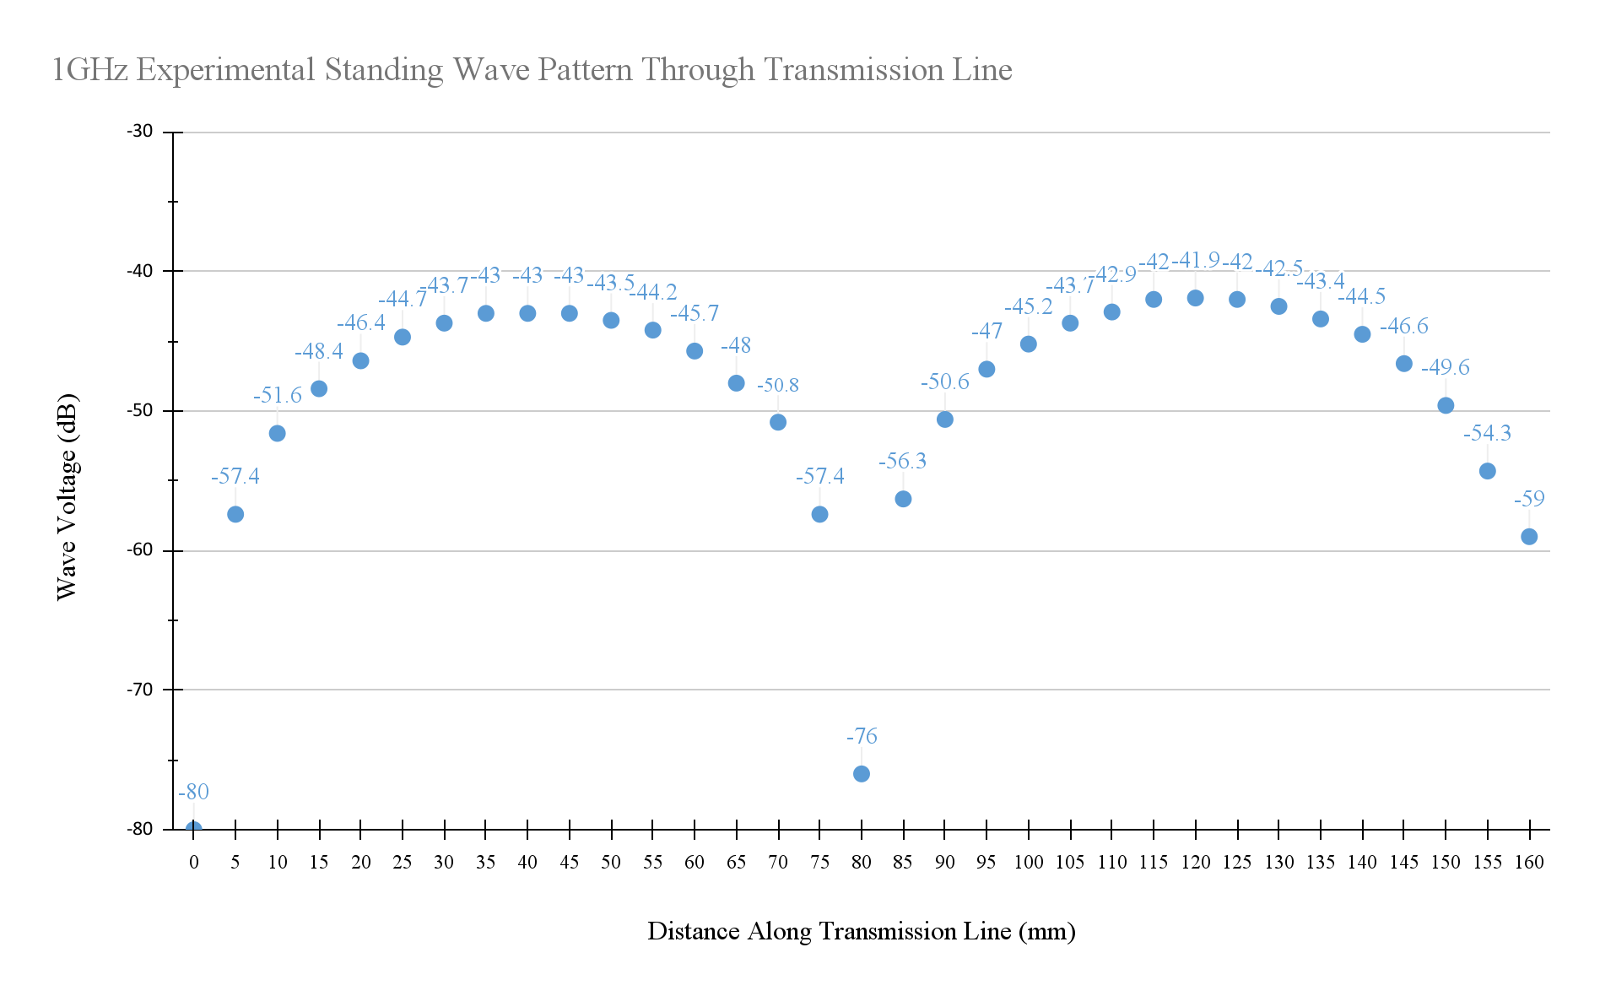

# **4.3 Using Standing Wave Patterns for Load Calculations**

*[ 5 ] Impedance of the load found from experimental standing wave measurement data.*

VSWR = |Vmax| / |Vmin|

VSWR = 0.004416 / 0.002239

VSWR = **1.9723**

**Finding magnitude of reflection coefficient**

|Γ| = (VSWR − 1) / (VSWR + 1)

|Γ| = (1.9723 − 1) / (1.9723 + 1)

|Γ| = 0.9723 / 2.9723

|Γ| = **0.327122**

**Finding phase of reflection coefficient**

θr = 2 **×** (2πf / Vp) **×** distance at min

θr = 2 **× ((**2π **×** 109) / 1.6**×**108 m/s) **×** 0.135m

θr = 10.6029−2π

θr = **4.31969**

**Finding complex value of reflection coefficient**

|Γ| = 0.327122

θr = 4.31969

Γ = **−0.1251841 − j0.3022213**

**Finding load impedance**

Reflection coefficient formula:

Γ = (ZL − Z0) / (ZL + Z0)

Rearranging:

Γ **×** ZL + Γ **×** Z0 = ZL − Z0

Γ **×** Z0 + Z0 = ZL − Γ **×** ZL

ZL (1 − Γ) = Z0 (Γ+ 1)

Rearranged to find Load Impedance:

ZL = (Z0 (Γ + 1)) / (1 − Γ)

Γ = **−0.1251841 − j0.3022213**

Z0 = **50 Ω**

ZL = (50 **×** (−0.1251841 − j0.3022213 + 1)) / (1 − (−0.1251841 − j0.3022213))

ZL = (50 **×** (0.8748159 − j0.3022213)) / (1.1251841 + j0.3022213)

ZL = **32.89421 − j22.26491 Ω**

*[ 5 ] Impedance of the load measured using the vector network analyzer (VNA).*

ZL = **31.80 + j10.92 Ω**

L = **1.739 nH**

*[ 5 ] Comparison of results.*

We obtained an experimental load impedance of ZL = **32.89421 − j22.26491 Ω**. The real part of the impedance is close to our theoretical value, but the imaginary part is negative (**−**j22.3Ω**)** when we expected it to be a positive value (j10.9Ω**)**.

With multiple measurements, our values did not significantly improve, so we assume that some part of our measurement process introduced errors to our data. If we use the VNA measured load impedance and work backwards, we compute a reflection coefficient of **−**0.201088 + j0.1603409. If we compare this to the coefficient we obtained from our experimental values, we see that the measured imaginary component should be positive rather than negative.

*[ 15 ] Plotting the experimental standing wave pattern.*

